# User Roles Description

Contents

Content 1

Document Revision 1

User Roles 1

Permissions 2

User roles 3

System Level: System admin 3

Organization Level: Organization admin 4

Organization Level: Manager 4

Organization Level: Associate 5

Organization Level: Analyst 6

Outside organization: Client 6

Outside organization: Participant 7

# Document Revision

|  |  |  |  |
| --- | --- | --- | --- |
| Revision Date | Summary of Changes | Version No. | Author |
| 26 August 2015 | Initial Draft | V0.1 | Maria Lotsman |
|  |  |  |  |

.

# Business process flow

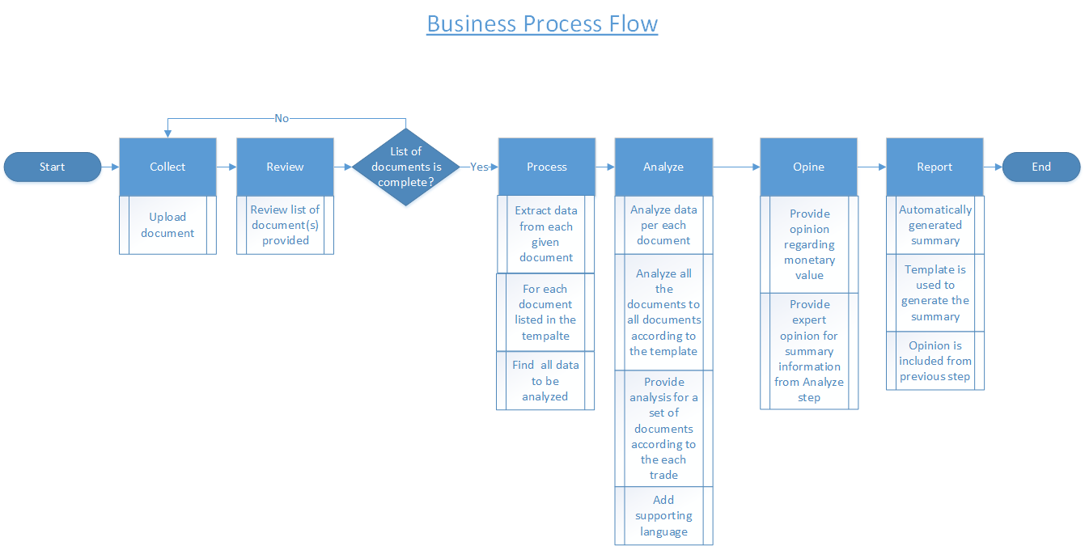

Please, see below the process described step by step.

1. Collect
   * Users upload the documents into the system on this step.
   * Users see what is required and what is provided.
   * User/system checks the due date and take action if needed (i.e. notify user about close due date etc.).
2. Review
   * User sees the list of the documents provided, and if all the necessary documents were provided, goes to the next step.
3. Process
   * For a given document data is being extracted. In order to do this operation document need to be listed in the template -
   * It is normal to have documents without trade type; Such documents will play important role in nonstructural process, specific to the client
4. Analyze
   * 1st round is to analyze documents for the fund documents.
   * 2nd round is to analyze documents for the trade documents.
   * System shall aggregate the data.
   * System/user analyzes the data that was extracted as a whole picture.
   * System/user analyzes all the documents to all documents that were specified in the template.
   * System/user compare whether all data that was specified to be extracted is provided.
   * User check for additional documents (understand how the document suits the purpose).
   * System with user provides analysis for a set of documents according to the each trade.
   * User adds supporting language to the information (i.e. by filling in report section with statement of facts without personal opinion).
5. Opine
   * User provides expert opinion for summary information from the previous step.
   * User opinion regarding monetary value (this will influence the final report for the fund).
6. Report
   * System automatically generates information regarding the template.
   * System provides statement of facts from analyst.
   * User provides opinion / conclusion.

There are several roles within the system. Each role dictates which permissions user have, and from there what can be done within the system by this user. In order to understand why these roles are present within the system, and what is done by the users, please, see the business process flow described below:

1. Within the Organization
   1. Organization’s Admin
   2. Manager
   3. Associate
   4. Analyst
2. Outside the organization
   1. Client
   2. Participant
3. Within the system:
   1. System Admin

Please, see below the picture which illustrates within which step of business process flow each role is involved.

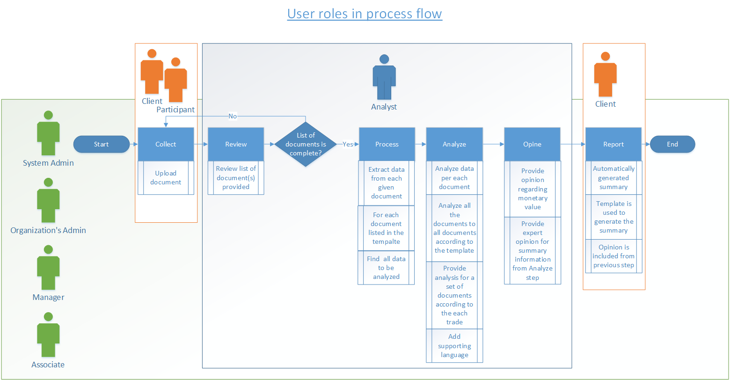

## Permissions

Each role within the system has a specific set of permissions. Please, see below summary table of these permissions.

|  |  |  |  |  |  |  |  |
| --- | --- | --- | --- | --- | --- | --- | --- |
| **Permissions\Role** | **System Admin** | **Organization**  **Admin** | **Manager** | **Associate** | **Analyst** | **Client** | **Participant** |
| Collect (Download)t | All | All within the Organization | All within the Organization | Within assigned project(s) | None | Only within client’s space | Only within assigned space |
| Review | All | All within the Organization | All within the Organization | Within assigned project(s) | Within assigned project(s) | None | None |
| Process | All | All within the Organization | All within the Organization | Within assigned project(s) | Within assigned project(s) | None | None |
| Analyze | All | All within the Organization | All within the Organization | Within assigned project(s) | Within assigned project(s) | None | None |
| Opine | All | All within the Organization | All within the Organization | Within assigned project(s) | Within assigned project(s) | None | None |
| Report | All | All within the Organization | All within the Organization | Within assigned project(s) | Within assigned project(s) | None | None |
| Upload | All | All within the Organization | All within the Organization | Within assigned project(s) | None | Read only | None |

Please, see below description of each role.

## User roles

### Organization Level

#### Organization admin

Organization Admin is a user which serves as an administrator for a specific organization within the application. Organization Admin has technical knowledge and experience to manage users, templates and projects within the system. An Admin is the super-user of the system and can perform both business and system functions such as creating new users and setting user roles. Organization Admin have access to all the process within the system for his/her organization. That means s/he can collect (upload documents) review a document list process documents analyze documents opine and report. Organization admin can assign users to project.

#### Manager

Manager is a user which serves as an administrator for a specific project or fund within the organization. Manager has subject matter expertise and experience to manage users, templates and projects within the organization. A Manager can perform any business function within the system and will spend their time on a mixture of monitoring work, reviewing work, and performing work at the Trade and Fund level. Manager has access to all the process within the system for his/her organization. That means s/he can collect (upload documents) review a document list process documents analyze documents opine and report. Manager can assign users to project.

#### Associate

Associate is a user which serves as an administrator for a specific project (usually project 1 or multiple funds) within the organization. Associate has technical knowledge and experience to work with provided documents and available templates provided for a specific project. Associate has access to all the process within the project(s) s/he is assigned to. That means s/he can collect (upload documents) review a document list process documents analyze documents opine and report. An Associate is mostly focused on Transaction level documents and analysis (the next section details the data hierarchy). While these will aggregate up to Trades, where some additional analytical work will be done, they will collect, analyze, process, opine, and report upon Transactions in support of the Manager who is working on the Trades and Funds.

#### Analyst

Analyst is a user which serves as a person who views and evaluates the data for a specific projectwithin the organization. Analyst has little subject matter expertize and not much experience to work with provided documents and available templates to evaluate the data available. An Analyst is someone who can assist an Associate with some of the document analysis, processing, and opinion work. Associate has access to all the process within the project(s) s/he is assigned to except collection and reporting. That means s/he can review a document list, process documents, analyze documents and opine.

### Outside organization

#### Client

Client is a user which serves as a person who provides the documents and for whom the analysis takes place. Client can only provide the documents and access to the final report. That means s/he cannot review a document list, process documents, analyze documents and opine.

#### Participant

Participant is a user which serves as a person who helps client to provide the documents. Participant can only provide the documents. That means s/he cannot review a document list, process documents, analyze documents, opine and report.

### System Level

#### System admin -

System Admin is a user which serves as an administrator for the application system. System Admin has technical knowledge and experience to manage users, organizations and projects within the system. System Admin have access to all the process within the system for his/her organization. No data management but only system management is done by system admin.

# Profile settings - TBA

Every user within the system shall have a profile, where he can manage his settings, view available information for s/he. Please, see specifics for each user described below.

## Common functionality

## Organization Level

### Organization Admin

Organization Admin can do such things within the profile management functionality:

* Manage permissions for user’s who belong to his/her organization
* Invite user to the organization
* Access/view all Projects which belong to his/her organization

User profile settings:

|  |  |  |  |  |
| --- | --- | --- | --- | --- |
|  | | **Business rule** | |  |
|  | All users can reset their own password. | |  | |
|  | All users can leave the organization they are assigned to. | |  | |
|  | A limited amount of users can manage user permissions. | |  | |
|  | All users can edit their personal information. | |  | |

Send Invite Functionality

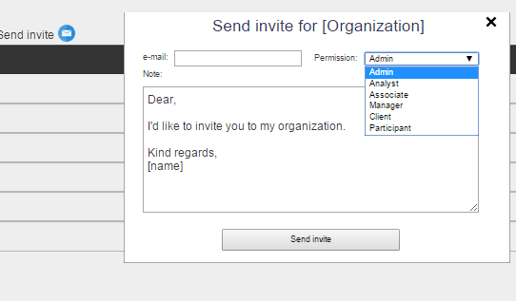

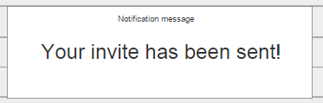

|  |  |  |
| --- | --- | --- |
|  | **Business rule** |  |
|  | Organization Admin can invite a new user to the organization with such permissions: client, participant, manager, analyst, associate, admin (?) |  |
|  | Manager can invite a new user to the organization with such permissions: client, participant, and analyst, associate. |  |
|  | Client can invite a new user to the organization only with participant permission. No drop down for the client with permission is available. |  |
|  | Analyst and associate cannot invite people to organization. |  |
|  | After the invite is sent successfully the message is given to a user. |  |

Please, see UI for the following functionality:

**Organization Account Full View**

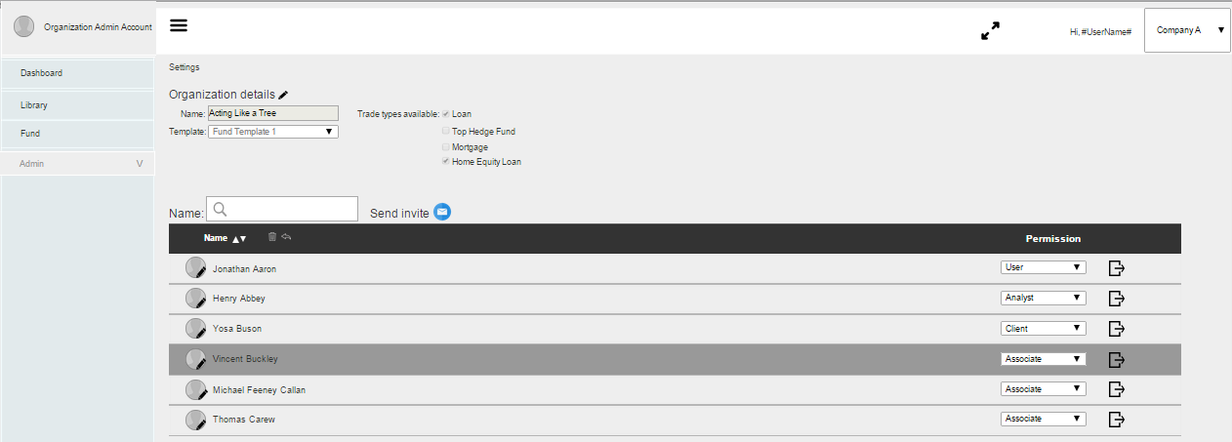

**Organization Account User profile management**

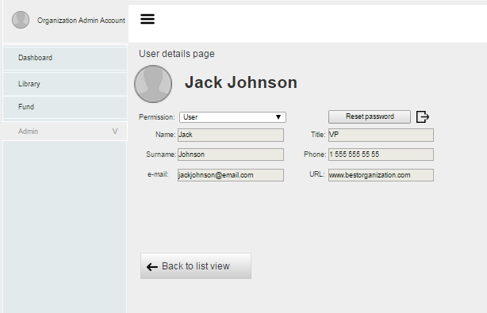

**Organization Account Send Invite**



Please, see Organization Admin business rules.

|  |  |  |
| --- | --- | --- |
|  | **Business rule description** | **UI link** |
|  | Organization Admin shall have access to all user profiles with no possibility to change personal data. |  |
|  | Organization Admin shall have access to all user profiles with possibility to resent user’s permissions within the system for his/her organization. |  |
|  | Organization Admin shall be able to view all projects within the organization. |  |
|  | Organization Admin shall be able to view all information about user. |  |
|  | Organization Admin can send invite user to the organization. |  |

### Manager

Manager can do such things within the profile management functionality:

* Access/view all Projects which belong to his/her organization
* Can do everything on the project level

**Manager Account View**

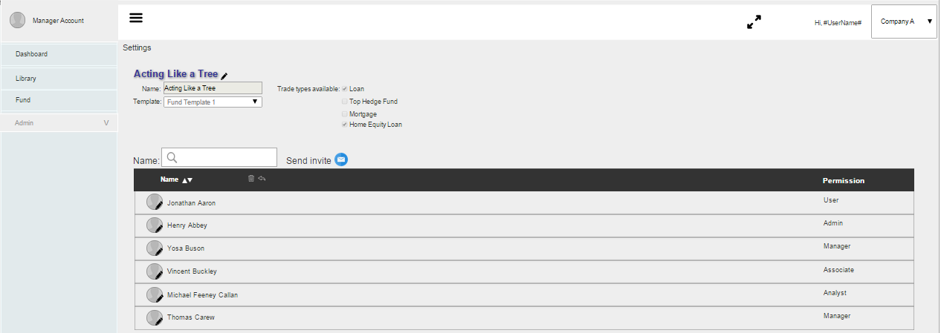

**Manager Account User profile management**

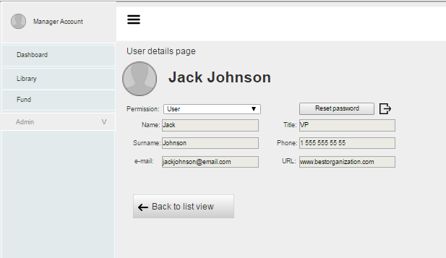

Please, see Manager Admin business rules.

|  |  |  |
| --- | --- | --- |
|  | **Business rule description** | **UI link** |
|  | Manager shall have access to all user profiles with no possibility to change personal data. |  |
|  | Manager shall have access to all user profiles with possibility to resent user’s permissions within the system for his/her organization. |  |
|  | Manager shall be able to view all projects within the organization. |  |
|  | Manager can send invite user to the organization. |  |

### Associate

Associate can do such things within the profile management functionality:

* Can change personal information
* Can leave the organization
* Can switch between different organization’s
* Can change password

**Associate Account Admin View**

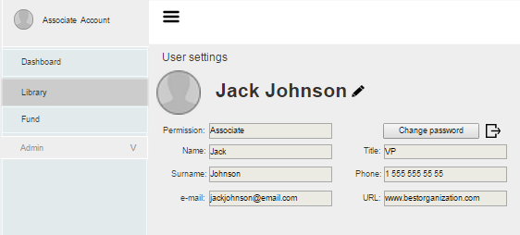

**Associate Account Admin View Edit mode**

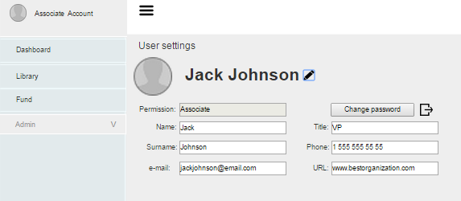

Please, see Associate business rules.

|  |  |  |
| --- | --- | --- |
|  | Business rule description | UI link |
|  | Associate has access to his/her own user profile with possibility to change personal data. |  |
|  | Associate cannot resent user’s permissions or his/her own permission. |  |
|  | Associate shall be able to view only the projects he/she is assigned to. |  |
|  | Associate cannot send invite user to the organization. |  |
|  | Associate can leave the organization. |  |

### Analyst

Analyst can do such things within the profile management functionality:

* Access/view all project to which is assigned
* Can change personal information
* Can leave the organization
* Can switch between different organization’s
* Can change password

**Analyst Account View**

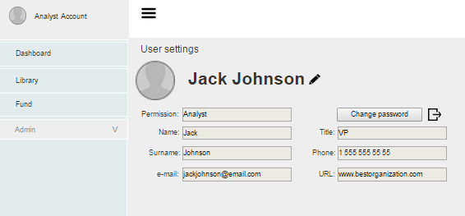

**Analyst Account View Edit Mode**

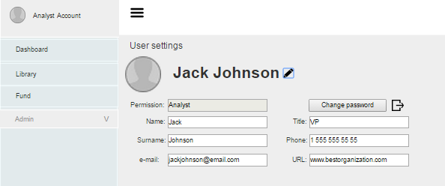

Please, see Analyst business rules.

|  |  |  |
| --- | --- | --- |
|  | **Business rule description** | **UI link** |
|  | Analyst has access to his/her own user profile with possibility to change personal data. |  |
|  | Analyst cannot resent user’s permissions or his/her own permission. |  |
|  | Analyst shall be able to view only the projects he/she is assigned to. |  |
|  | Analyst cannot send invite user to the organization. |  |
|  | Analyst can leave the organization. |  |

## Outside Organization

### Client

Client can do such things within the profile management functionality:

* Access/view projects which user is assigned
* Can change personal information
* Client is/has organization, they are on a project
* No switching between organizations
* Can change password

**Client Account View**

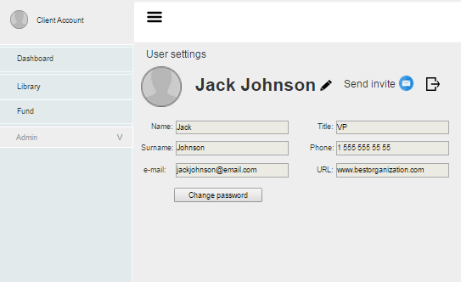

**Client Account View Edit Mode**

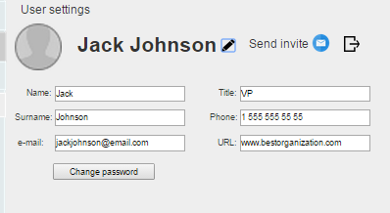

**Client Account View Send Invite**

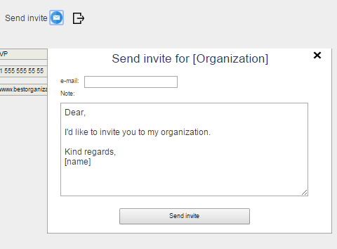

Please, see Client business rules.

|  |  |  |
| --- | --- | --- |
|  | **Business rule description** | **UI link** |
|  | Client has access to his/her own user profile with possibility to change personal data. |  |
|  | Client cannot resent user’s permissions or his/her own permission. |  |
|  | Client shall be able to view only his/her projects **(projects, to which s/he was invited to)** |  |
|  | **Client can send invite user to the organization with participant permission only** |  |
|  | Client can leave the organization. |  |

### Participant

Participant can do such things within the profile management functionality:

* Access/view projects which user is assigned
* Can change personal information
* Can leave the organization
* No switching between organizations
* Can change password

**Participant Account View**

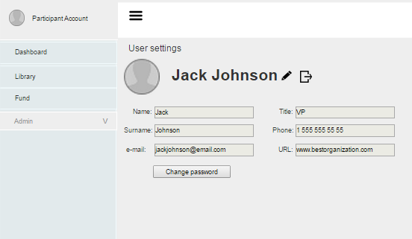

**Participant Account View Edit Mode**

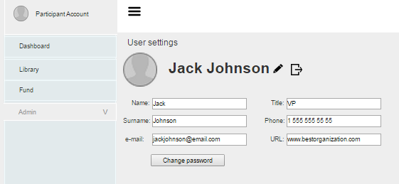

Please, see Participant business rules.

|  |  |  |
| --- | --- | --- |
|  | **Business rule description** | **UI link** |
|  | Participant has access to his/her own user profile with possibility to change personal data. |  |
|  | Participant cannot resent user’s permissions or his/her own permission. |  |
|  | Participant shall be able to view only his/her projects **(projects, to which s/he was invited to)** |  |
|  | Participant **cannot send invite user.** |  |
|  | Participant can leave the organization. |  |

## System Level

### System Admin

System admin can do such things within the profile management functionality:

* Reset user password (user can relate to many organizations)
* Change user’s email
* Search though the list with Name filter and Organization filter

Please, see below UI Profile Setting for System Admin.

System Admin Profile Page1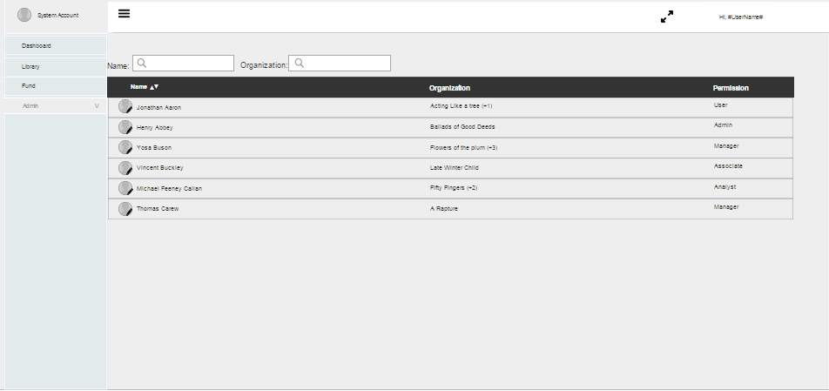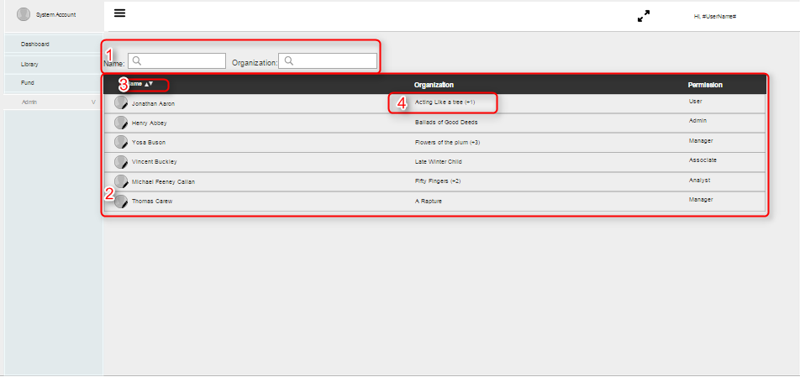

System Admin Organizations Expanded View

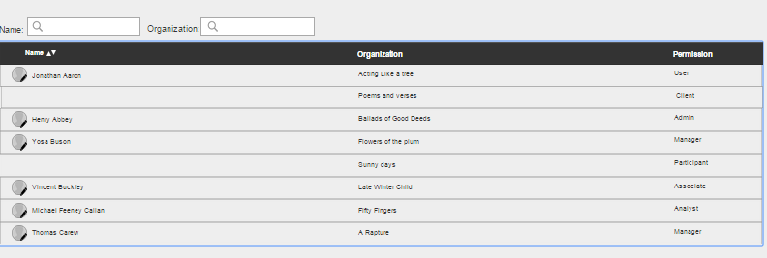 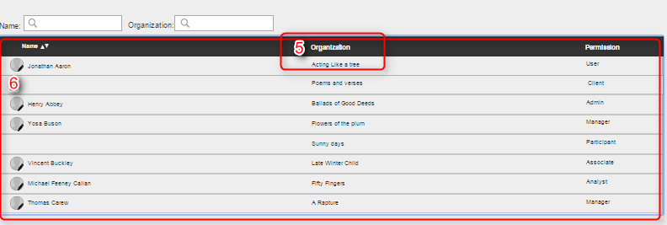

System Admin View: User Profile View

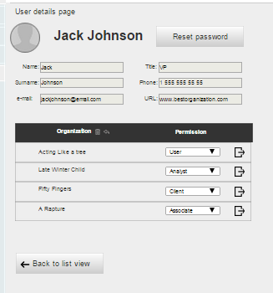 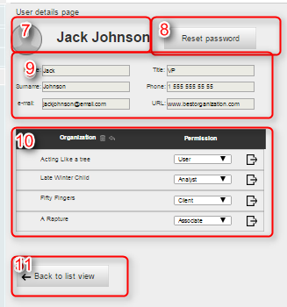

Please, see System Admin business rules.

|  |  |  |
| --- | --- | --- |
|  | **Business rule description** | **UI link** |
|  | System Admin shall have access to all user profiles with possibility to resent user’s password within the system. |  |
|  |  |  |
|  | System Admin shall have access to all user profiles with no possibility to change personal data. |  |
|  | System Admin shall have access to all user profiles with possibility to resent user’s permissions within the system. |  |
|  | System Admin shall be able to view all projects within the organization. |  |
|  | System Admin shall be able to view all information about user. |  |
|  | System Admin cannot create project, or fund. |  |
|  | System Admin cannot modify or create fund or trade template. |  |
| 1 | System Admin can search via User Name, Organization Name. Search shall have technical characteristic as the one used for the Library functionality (elastic search with close to real time search ~0.5, minimum 3 characters). | Please, see **System Admin.** |
| 2 | System Admin shall be able to view the list of Users with the name of the organization they belong, and which permission they have (within that organization). |  |
| 3 | System Admin can filter the User list via Name (A-Z, Z-A). |  |
| 4. | When user belongs to more than 1 organization, display Organization name and next to it amount of organization to which user belongs. Show the one organization in User list, which is alphabetically comes first (i.e. if user belongs to Aaron Morris Inc. and British Tabaco Company, display *Aaron Morris +1).* |  |
| 5 | Via click on the Organization Header user can expand the User list. |  |
| 6 | User List Expanded view where System Admin can see Users with all the organizations they belong to in one view. |  |
| 7 | User’s name in the system, no action via click. |  |
| 8 | Action button [reset password]. Via click user gets additional fields to manage his/her password. |  |
| 9 | Personal information fields. |  |
| 10 | List of the organizations to which user belongs, with permission which is assigned to the user. |  |
| 11 | [Back to list] action button, via click user goes back to the user list. |  |

System Admin Organization View

